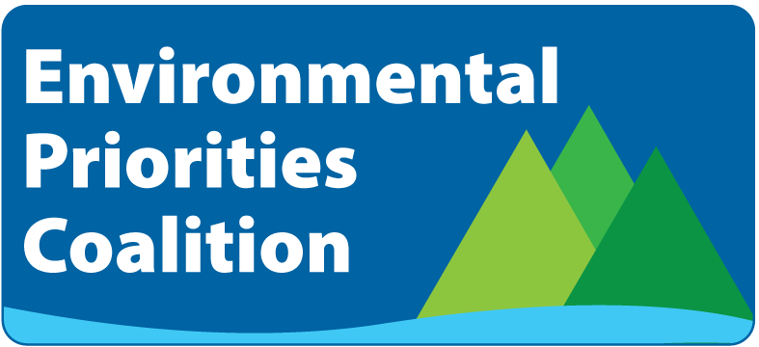

2018 Environmental Priorities Overview

Protect Clean Water and Create Jobs through Water Quality Infrastructure Investments
Maine’s clean water is vital for our economy and our quality of life, but Maine waters face pollution risks from storm water runoff and untreated sewage. Many communities, especially rural towns and water districts, do not have the financial capacity to address deteriorating infrastructure or make needed improvements to camp roads. Investments in wastewater and road infrastructure are needed now. Clean water bonds will leverage other funding, protect and restore Maine waters, and create good jobs.
Support LD 178 and LD 1510 Sponsored by Rep. Russell Black (LD 178) and Maine DEP (LD 1510)
RESOLUTION: SUCCESS! BILL ENACTED INTO LAW.
Protect Maine Families and Businesses from Unnecessary Electric Bill Increases and Fees
Maine families and businesses should have the right to generate their own power and increase their energy security. But the Public Utilities Commission (PUC) is about to impose an unfair and radical new fee on power that never touches the electrical grid. LD 1444 would have eliminated this new fee, prevented the need for costly new meters, and carefully reduced barriers for community solar. LD 1444 supported Mainers generating their own power while protecting all consumers from higher electricity rates.
Support LD 1444 Sponsored by Sen. David Woodsome
RESOLUTION: FAILED. GOVERNOR’S VETO OVERRIDE LOST BY 2 VOTES.
Save Tax Dollars, Address Hunger, and Reduce Food Waste in Maine
We all have a stake in making sure Maine kids don’t go hungry and that our farmers’ food isn’t wasted. Maine has the nation’s third highest rate of hunger, yet nearly half of our food goes to waste. Wasted food is the single largest and most expensive component, by weight, of municipal and school solid waste. LD 1534 will help schools develop waste reduction programs and it will support businesses that donate or discount food that would otherwise be wasted. LD 1534 will save money and address hunger, while creating new market opportunities for farmers.
Support LD 1534 Sponsored by Rep. Craig Hickman
RESOLUTION: SUCCESS! PASSED UNANIMOUSLY INTO LAW WITHOUT GOVERNOR’S SIGNATURE.
Don’t Weaken Maine’s Renewable Energy Policy
Renewable energy keeps Maine on the path to energy independence. Developing new, local renewable resources creates jobs, increases tax revenue, and strengthens the overall Maine economy. But LD 1699 would have allowed older, existing renewable resources to be included in Maine’s Renewable Portfolio Standard (RPS) without additional investments or improvements, thereby suppressing investment in new renewable generation. Maine needs comprehensive RPS reform that strengthens our renewable energy laws. LD 1699 would have taken us in the wrong direction.
Reject LD 1699 Sponsored by Rep. Deane Rykerson
RESOLUTION: SUCCESS! BILL DIED IN ENERGY, UTILITIES, AND TECHNOLOGY COMMITTEE.
Support Maine’s Fishing Industries and Stop Blocking Sea-Run Fish from Sheepscot Pond
Protecting Maine’s recreational and commercial fishing industries is about preserving our way of life and an important resource for our children. Alewives and other sea-run fish are critical food sources for many species of birds, mammals, and ground fish. Despite their important role in the aquatic food chain, native sea-run fish are currently being blocked from Sheepscot Pond based on the unscientific belief that they are a danger to freshwater game fish. LD 1667 would have put this unfounded practice into law. This bill posed a grave threat to alewives, other native sea-run species, and the long-term health of Maine’s fishing industries.
Reject LD 1667 Sponsored by Rep. Stanley Zeigler
RESOLUTION: SUCCESS! BILL DIED IN INLAND, FISHERIES, AND WILDLIFE COMMITTEE.
Protect Clean Transportation Choices for Mainers
We all benefit from less-polluting cars and trucks – the air is cleaner, our health is better, and we’re one step closer to energy independence. Maine drivers shouldn’t be taxed for choosing fuel-efficient vehicles that reduce gasoline imports, use locally-produced energy, create less carbon pollution, and keep more money in Maine’s economy. LD 1806 would have taxed hybrid and all electric vehicles and would not have raised significant enough revenue to put a dent in Maine’s transportation funding shortfall.
Reject LD 1806 Sponsored by Maine DOT
RESOLUTION: SUCCESS! BILL DIED IN SENATE 19-15.

For more information, please contact Beth Ahearn, 207-671-5071 or beth@protectmaine.org

